PROOF OF TEST
SIGN IN:

VALIDATION:
Enter the URL in any window , Login Page should be displayed

EXPECTED RESULT:
Login page should be displayed successfully

SCREENSHOT:



WEB ELEMNTS OVER THE SCREEN:

VALIDATION:

Verify that the login screen contains elements such as "Username"," Password", "Submit Button" "Forget Button"

EXPECTED RESULT:
All the web elements should be available on the screen successfully

SCREENSHOT:

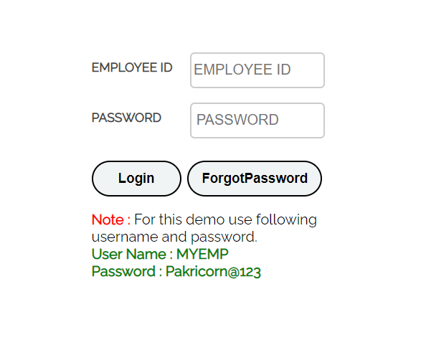
HEADER:
VALIDATION:

Verify the icons aligned with the text over the "header

EXPECTED RESULT:
Icons aligned with the text should be displayed successfully

SCREENSHOT:
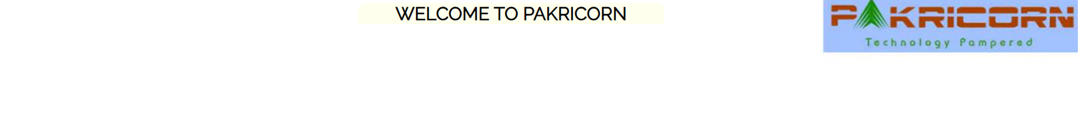

EMP ID TEXT-BOX:
VALIDATION:
Verify that all the fields such as "EMP ID" with the text box and should be clickable

EXPECTED RESULT:
Emp ID & Text Box should be clickable Sucessfully

SCREENSHOT:
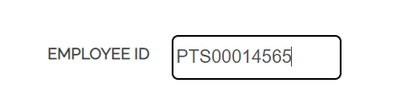

PASSWORD TEXT-BOX:
VALIDATION:
Verify that all the fields such as "PassWord" with the text box and should be clickable

EXPECTED RESULT:
Passowrd Text Box should be clickable successfully

SCREENSHOT:
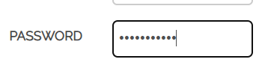

LOG IN:
VALIDATION:
Verify the "Submit button" along with the text in it should be available. it should be clickable and highlighted

EXPECTED RESULT:
The Submit Button should be aligned properly with the text and it should be clickable

SCREENSHOT:
Login Button Highlight



FORGOT PASSWORD BUTTON:

VALIDATION:
Verify the "Forget button" along with the text in it should be available it should be clickable and highlighted

EXPECTED RESULT:
Forget Button should be aligned properly with in the text and it should be clickable

SCREENSHOT:
Forget Button Highlight

